Naval Enterprise Resource Planning Architectur

Design by Laksamana Pertama TNI Judijanto

For a Navy ERP, I would not simply copy a commercial ERP and rename the modules. The better design is to build a Naval Enterprise Resource Planning Architecture in which finance, logistics, personnel, maintenance, procurement, assets, documents, and command information are connected around one central object: naval readiness.
Your eight areas are an excellent administrative foundation. I recommend expanding them into a 12-domain Navy ERP architecture so the system supports both headquarters management and operational fleet readiness.
NAVY ERP — Integrated Enterprise Architecture
Strategic objective:
One Navy – One Data – One ERP – One Common Enterprise Picture
The architecture should connect:
Planning → Budget → Procurement → Contract → Inventory → Distribution → Ship/Base → Maintenance → Personnel → Operations → Financial Accountability → Command Decision
1. Core Business Architecture
ERP Domain | Navy ERP Function | Principal Capabilities
💰 Finance & Accounting | Financial Resource Management | Budget, AP/AR, payments, expenses, accounting, treasury, taxation, audit trail, cost accounting
📦 Inventory & Warehousing | Naval Supply Management | Stock, warehouses, ammunition/spares inventory, batch/serial tracking, stock transfers, minimum stock levels
🛒 Purchasing & Procurement | Defence Procurement Management | Vendors, RFQ/RFP, purchase requisitions, purchase orders, tenders, approvals, contract linkage
🤝 Demand / Service Management | Internal Customer & Requirement Management | Requirements from ships, bases, commands and units; quotations/cost estimates where applicable; service requests
🚢 Logistics & Transportation | Naval Logistics Management | Shipment, fleet distribution, cargo, transportation, delivery, ports, logistics routes, movement tracking
👥 Human Resources | Naval Human Capital Management | Personnel, organization, payroll, attendance, qualifications, competencies, training and assignments
📊 Management | Command & Management Information | Dashboards, KPIs, readiness indicators, financial reports, logistics reports, executive decision support
📄 Documents | Enterprise Document & Records Management | Contracts, invoices, certificates, technical manuals, procurement files, shipping documents, correspondence
⚙️ Maintenance / MRO | Fleet Maintenance Management | Preventive/corrective maintenance, work orders, docking, engineering history, spare-parts consumption
🚢 Fleet & Asset Management | Naval Asset Lifecycle Management | Ships, aircraft, vehicles, weapons, sensors, machinery, infrastructure and lifecycle records
🏗️ Infrastructure | Base & Facility Management | Naval bases, docks, warehouses, fuel facilities, buildings, utilities, infrastructure maintenance
🎯 Readiness Management | Force Readiness & Resource Integration | Material, personnel, training, supply and maintenance readiness consolidated for commanders
This changes the ERP from an administrative system into a Naval Readiness Management System.

2. Recommended Navy ERP Architecture
I would structure the architecture into seven layers:

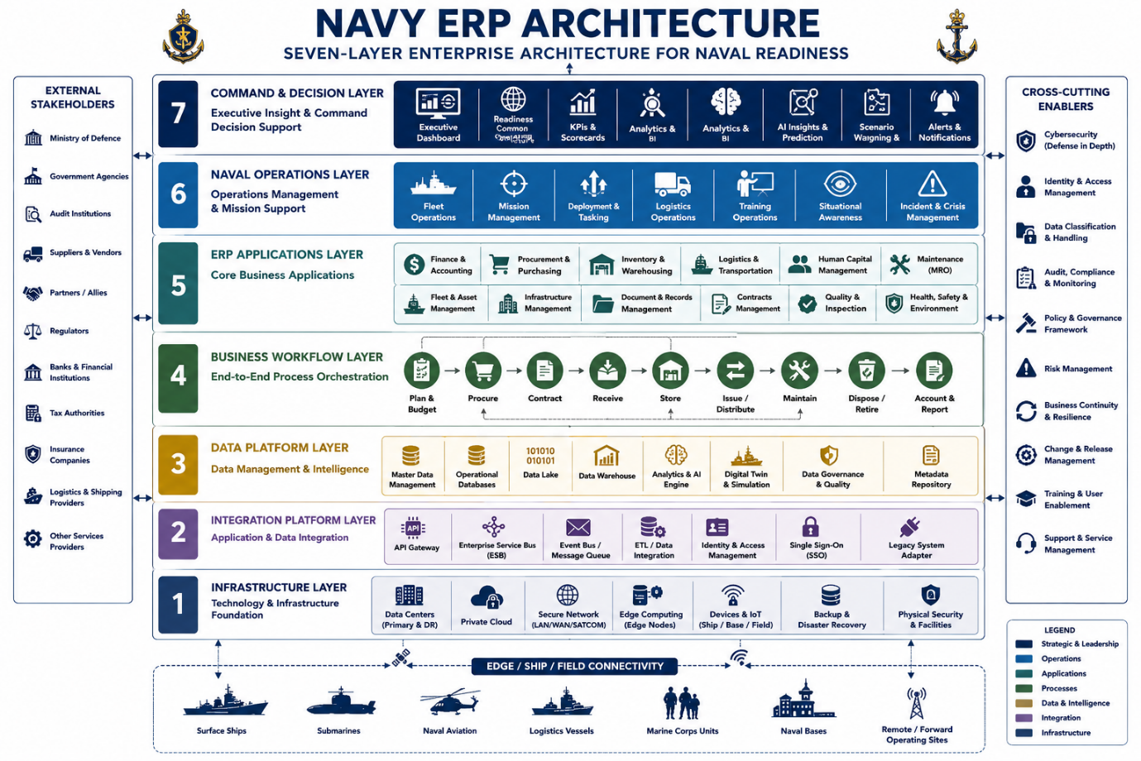

Surrounding every layer should be:
Cybersecurity + Identity + Classification + Audit + Governance + Business Continuity

3. The Most Important Architectural Principle
For a Navy, the ERP should revolve around a Naval Enterprise Digital Thread.
For example:
Ship → Equipment → Maintenance Requirement → Spare Part → Warehouse → Procurement → Supplier → Contract → Payment → Budget → Readiness
Consider a propulsion-system failure.
The ERP should automatically be able to identify:
KRI / SHIP
↓
Main Engine
↓
Equipment Serial Number
↓
Failure Report
↓
Maintenance Work Order
↓
Required Spare Part
↓
Inventory Check
↓
Available?
/ \
YES NO
| |
Issue Procurement Request
| |
Ship Tender / Purchase Order
| |
Install Supplier
\ /
↓
Maintenance Complete
↓
Technical Inspection
↓
Asset Status Updated
↓
READINESS UPDATED
↓
COMMAND DASHBOARD
This is where naval ERP becomes strategically valuable.

4. Finance & Accounting Architecture
Your Finance module should be much broader than invoices and payments.
It should support:
Strategic Planning → Program → Budget → Commitment → Procurement → Contract → Payment → Accounting → Audit
The Navy needs to see not merely:
"How much money has been spent?"
but:
"How much combat readiness did that expenditure produce?"
The hierarchy could therefore be:
National Defence Budget
↓
Navy Budget
↓
Command
↓
Program
↓
Activity
↓
Unit
↓
Asset
↓
Ship
↓
Equipment
↓
Cost
This enables Total Cost of Ownership (TCO) calculation for every major platform.

5. Naval Inventory Architecture
Inventory is particularly important because Navy inventory is not a normal retail warehouse.
I recommend six inventory categories:
Category | Examples
Technical Spares | engines, pumps, valves, electronic modules
Consumables | lubricants, filters, ropes, paints
Fuel & Energy | marine fuel, aviation fuel, lubricants
Ammunition | controlled inventory
General Supplies | uniforms, office supplies, food
Strategic Reserves | critical war reserve materials
Each item should have a Unique Material ID linked to:
NSN/material code → manufacturer → part number → equipment → ship class → warehouse → quantity → location → procurement history → price → remaining life.

6. Procurement Architecture
A Navy ERP procurement module should provide an integrated Procure-to-Pay workflow:
Requirement
↓
Purchase Requisition
↓
Budget Verification
↓
Technical Specification
↓
Procurement Method
↓
RFQ / Tender
↓
Vendor Evaluation
↓
Contract
↓
Purchase Order
↓
Delivery
↓
Inspection
↓
Goods Receipt
↓
Invoice
↓
Payment
↓
Vendor Performance
This creates much stronger transparency and auditability.

7. Logistics Architecture
For naval ERP, logistics should answer four fundamental questions:
What is required?
Where is it?
When will it arrive?
What mission depends upon it?
Therefore, logistics should integrate:
Warehouse + Transportation + Port + Ship + Supply + Maintenance + Mission requirements.
The ERP could generate a Naval Logistics Common Operating Picture, showing for example:
SURABAYA NAVAL BASE

Warehouse A
├── Engine spares
├── Electronic spares
└── Consumables

Fuel Depot
├── Marine fuel
└── Aviation fuel

Transport
├── Trucks
├── Supply vessels
└── Air transport

SUPPORTED UNITS

KRI A
KRI B
KRI C
Naval Aviation
Marine Corps Unit

8. Human Resources Architecture
Commercial ERP HR is insufficient for a Navy.
Navy HR should become a Military Human Capital Management System incorporating:
Personnel → Rank → Branch → Competency → Qualification → Certification → Medical/administrative readiness → Training → Assignment → Career → Deployment.
The important integration is:
PERSON
+
QUALIFICATION
+
TRAINING
+
ASSIGNMENT
+
PLATFORM
=
PERSONNEL READINESS
Therefore commanders can identify skill shortages before deployments.

9. Fleet Maintenance — A Critical Addition
I strongly recommend making Maintenance, Repair and Overhaul (MRO) one of the largest Navy ERP modules.
The asset hierarchy can be:
NAVY
↓
FLEET
↓
SHIP CLASS
↓
SHIP
↓
SYSTEM
↓
SUBSYSTEM
↓
EQUIPMENT
↓
COMPONENT
↓
PART
Example:
KRI XXX
├─ Propulsion
│ ├─ Main Engine 1
│ ├─ Main Engine 2
│ └─ Gearbox
│
├─ Electrical
│
├─ Navigation
│
├─ Communications
│
├─ Sensors
│
└─ Auxiliary Systems
Every component should carry maintenance history, operating hours, defects, technical documents, spare parts, lifecycle costs and condition information.

10. Documents Architecture
Your Document ERP module should become an Enterprise Document and Records Management System — EDRMS.
It should manage documents such as:
Contracts, technical specifications, invoices, purchase orders, certificates, drawings, equipment manuals, inspection certificates, shipping documents, maintenance records and official correspondence.
Every document should have:
Document ID
Version
Owner
Classification
Date
Related Unit
Related Asset
Related Contract
Related Procurement
Approval status
Digital signature
Retention policy
Audit history
The critical principle is that documents should not exist independently from ERP transactions.
For example:
Contract → Vendor → Purchase Order → Equipment → Ship → Invoice → Payment
should all be digitally linked.

11. Management and Command Dashboard
At senior leadership level, I recommend creating a Navy Enterprise Command Dashboard.
Rather than displaying hundreds of transactions, it should present a small number of strategic indicators.
NAVY ENTERPRISE READINESS DASHBOARD
Area | Key Indicator
Fleet | Operational Availability
Maintenance | Mission-Capable Rate
Logistics | Supply Availability
Inventory | Critical Spare Availability
Procurement | Procurement Lead Time
Finance | Budget Absorption
Personnel | Personnel Readiness
Training | Qualification Readiness
Infrastructure | Base Readiness
Fuel | Days of Supply
Contracts | Contract Performance
Enterprise | Overall Naval Readiness
Then the commander can drill down:
NAVY
↓
Fleet
↓
Command
↓
Base
↓
Ship
↓
System
↓
Equipment
↓
Individual Transaction

12. The Central Concept: NAVAL READINESS ERP
This is where I would modify the conventional ERP concept fundamentally.
Traditional ERP focuses on:
Revenue + Cost + Profit + Assets.
A military ERP should focus on:
Resources + Capability + Availability + Sustainability + Readiness.
Therefore:
$$Naval ERP=Finance+Personnel+Logistics+Procurement+Assets+Maintenance+Infrastructure+Information$$
but the output should be:
$$\boxed{NAVAL READINESS}$$
A more useful conceptual model would be:
$$NR=f\left(M , R , P , R , L , RTRFRIR\right)$$
where:
NR = Naval Readiness
MR = Materiel Readiness
PR = Personnel Readiness
LR = Logistics Readiness
TR = Training Readiness
FR = Financial Resource Readiness
IR = Infrastructure Readiness

13. Recommended Master Architecture
I would ultimately design the Navy ERP as five interconnected enterprise environments:
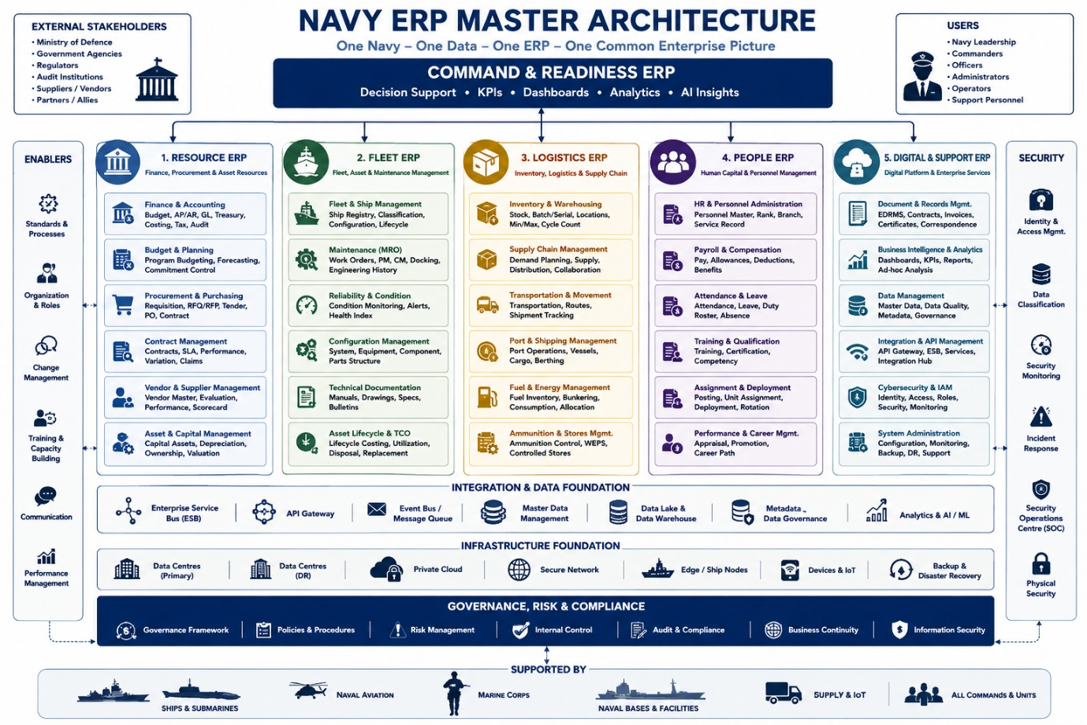

I would call the complete architecture:
NAVY ENTERPRISE RESOURCE & READINESS MANAGEMENT ARCHITECTURE — NER2MA
with five principal pillars:
Resource Management → Fleet Management → Logistics Management → Human Capital Management → Command & Readiness Management.
The especially important addition is the word Readiness. That differentiates a Navy ERP from SAP/Oracle-style commercial ERP implementation. The purpose is not merely digitizing administration; it is to provide commanders with a near-real-time understanding of the relationship between money, people, materiel, maintenance, logistics and fleet availability.
For the next stage, I recommend developing this into a full architecture with approximately 25–30 modules, followed by a Level-0 Navy ERP Enterprise Architecture diagram, Level-1 functional architecture, Level-2 application architecture, data architecture, integration/API architecture, cybersecurity architecture, ship–shore ERP architecture, and Navy ERP Command Dashboard architecture. That would be strong enough to form the basis of a formal Navy ERP Concept of Operations and system-design document.

